SESSION 1 LAB EXPERIMENT
EXP 5. Find Maximum Element — Least Time Complexity
#include <stdio.h>

int main()
{
int n;
int arr[100];

printf("Enter size of array: ");
scanf("%d", &n);

if (n <= 0)
{
printf("Array is empty\n");
return 0;
}

printf("Enter array elements:\n");

for (int i = 0; i < n; i++)
{
scanf("%d", &arr[i]);
}

int max = arr[0];

for (int i = 1; i < n; i++)
{
if (arr[i] > max)
{
max = arr[i];
}
}

printf("Maximum element = %d\n", max);

return 0;
}
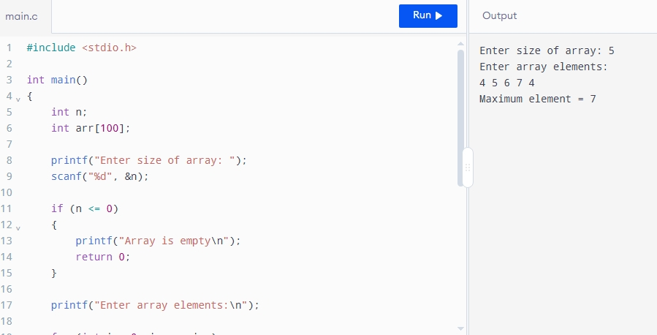

Time Complexity: O(n)
Space Complexity: O(1)

